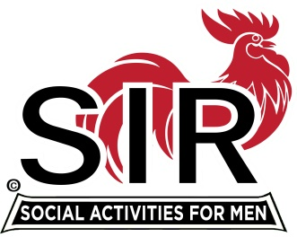
Las Trampas Branch 116
BEC Meeting Agenda
October 21, 2019, 9:30 AM
The Mission of SIR is to enhance the lives of our members through fun activities, events, and luncheons – while making friends for life.

09:15 Coffee Available
09:30 Call to order; Secretary confirm a quorum
09:31 Secretary – Fred Schafer – Approval of September 16 minutes
09:33 Treasurer – Jim Nickels – Report, Missed Luncheon Receipts
09:37 Standing Reports
- Attendance – Jim Flessner – Attendance, Guests and Visitors
- Membership – Phil Goff – New Members to be inducted,
- Department Head Reports: Activity Coord - Fred Wachowicz
09:47 Big SIR Report – Jerry Hicks
1. Good discussion of ideas at the last meeting. BEC is governing Board and Planning
2. Officer training for Big Sirs, Little Sirs, Secretaries, Treasurers, Membership Chairmen, and Nominating Committee Chairmen on Friday, November 1st from 10:00 A.M. to 2:00 P.M. The training will be held in the smaller Donner conference room at the Rossmoor Event Center, 1001 Stanley Dollar Dr., Walnut Creek, CA 94595
3. Branch Operating Manual.
09:50 Little SIR Report – Michael Barrington
1. Speaker: Nan Su
10:02 Old Business
- Discuss attendance requirement – 5 of 10 and 3 in a row follow up
- A Guest may attend for 3 times. Insurance requirement
- September discussion on how we are unique and how to integrate this into our image or branding? I heard golf, dynamic branch, seating at tables, committee structure, website/newsletter
10:07 New Business:
- Is there a way to cut down on the unexcused absences? How do we get more unexcused to pay?
10:15 Other Discussion
1. Review the Vision Statement: “To become the BEST ACTIVE MEN’S ORGANIZATION in Northern and Central California.”
10:20 Adjourn; Next BEC Meeting, November 18, 2019

